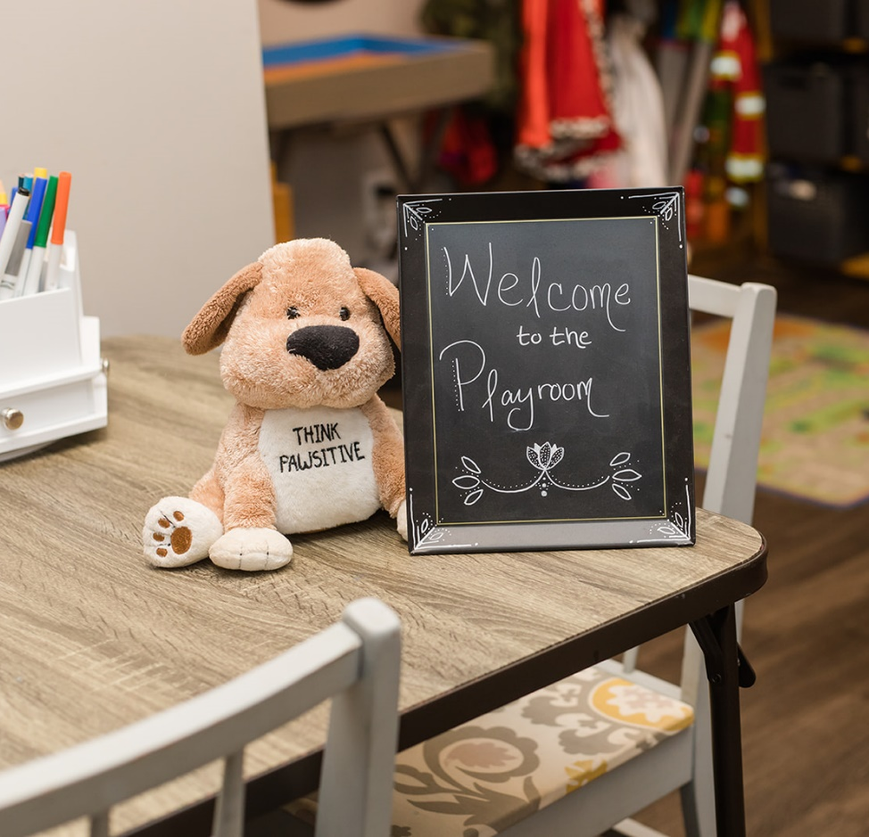
How to Become a Registered Play Therapist

How to Become a Registered
Play Therapist

Play therapy is a form of counseling that is used to help children deal with emotions and behavioral issues. It is a fun and interactive way for children to express
themselves, learn about their feelings, and develop new skills.

Use this checklist to understand the qualifications needed to become a Registered Play Therapist and track your progress as you work towards obtaining your
certification.

Primary Areas:

Phase 1 Requirements

Play Therapy History - 5 hours*

www.pawsforhealing.com
Play Therapy Seminal or Historically Significant Theories – 20 - 30 hours
Play Therapy Skills and Methods – 10 - 20 hours

Play Therapy Special Topics – 0 - 5 hours
Play Therapy Cultural and Social Diversity Topics – 6 hours Your choice - 15 hours*

Supervised Play Therapy:
Direct Client Contact Hours - 50 - 75 hours

Play Therapy Supervision:
Play Therapy Supervision - 5 - 10 hours
Required Session Observations - 1 session

*Can be completed in any phase
2

How to Become a Registered

www.pawsforhealing.com
Play Therapist

Phase 2 Requirements

Primary Areas:
Play Therapy Seminal or Historically Significant Theories – 25 - 30 hours
Play Therapy Skills and Methods – 25 - 30 hours Play Therapy Special Topics – 5 - 10 hours

Supervised Play Therapy:
Direct Client Contact Hours - 100 - 150 hours

Play Therapy Supervision:
Required Session Observations - 2 sessions Play Therapy Supervision - 10 - 15 hours

3

How to Become a Registered

www.pawsforhealing.com
Play Therapist

Phase 3 Requirements

Primary Areas:
Play Therapy Seminal or Historically Significant Theories – 10 - 15 hours
Play Therapy Skills and Methods – 15 - 20 hours Play Therapy Special Topics – 20 - 25 hours

Supervised Play Therapy:
Direct Client Contact Hours - 100 - 175 hours

Play Therapy Supervision:
Play Therapy Supervision - 10 - 20 hours
Required Session Observations - 2 sessions

4

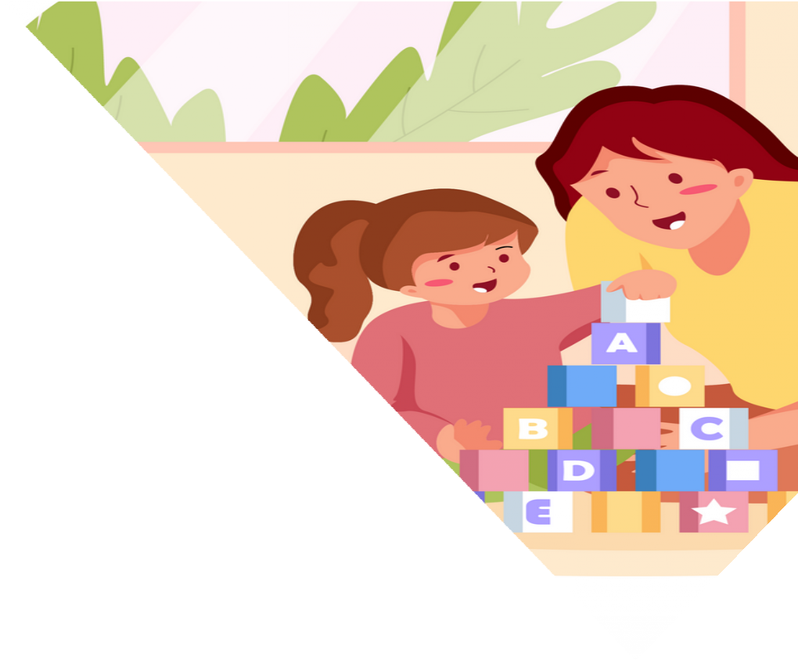How to Become a Registered

www.pawsforhealing.com
Play Therapist

Application Requirements

Once all required sections and phases have been completed, it ’ s time to gather all of your documentation, and submit your application.

Graduate transcripts

Current & active state l icense

Completed & signed Criteria Verification Form Application fee

Continuing Education

One of the final requirements for keeping up your APT certification is ongoing continuing education.

Every 36 months, you’ l l need to clock at least 24 hours of Play Therapy CE courses.

Continuing Education - 24 hours Play Therapy CE - 22 hours
Cultural & Social Diversity - 2 hours

Click here for a list of APT Approved Continuing Education Courses!

5

